**HVAC Smart App**

*An Industrial Training Project Report Submitted*

*to*

**MANIPAL ACADEMY OF HIGHER EDUCATION**

*For Partial Fulfilment of the Requirement for the*

*Award of the Degree*

*Of*

**Bachelor of Technology**

*in*

**Computer and Communication Engineering**

*by*

**Yuvraj Aloke**

**210953310**

*Under the guidance of*

Mr. Rahul Chandrashekar

General Manager

Heading Automotive ABS Unit for **Endurance Technologies**.

**September 2024**

**Final Report: Automobile HVAC Control Application**

1. **Introduction**

**1.1 Purpose**

This document is a comprehensive report detailing the requirements and specifications for the development of an Automobile HVAC Control Application using Flutter and Dart. The application leverages Gemini AI’s speech-to-text capabilities for voice-controlled interactions and utilizes real-time weather and traffic data to optimize climate settings. Additionally, it supports user profiles with preset functionalities to streamline climate control. This report covers version 1.0 of the application and includes all necessary system components to deliver the specified functionalities.

**1.2 Document Conventions**

* **Bold text**: Primary requirements and section headers.
* *Italic text*: Supplementary information and examples.
* [Priority: High/Medium/Low]: Priority level of requirements.

**1.3 Intended Audience and Reading Suggestions**

* **Developers**: Understand technical specifications and implementation requirements.
* **Project Managers**: Plan, allocate resources, and track progress.
* **Marketing Staff**: Gain insight into product features and capabilities.
* **Users**: Learn about the functionalities and benefits of the application.
* **Testers**: Create test plans and validate the application against requirements.
* **Documentation Writers**: Prepare user manuals and help guides.

**1.4 Project Scope**

The Automobile HVAC Control Application aims to enhance user experience through intuitive voice commands, real-time weather and traffic-based adjustments, and personalized climate control via user profiles. It aligns with broader business objectives of increasing user satisfaction and incorporating advanced technology to improve vehicle comfort and convenience.

**1.5 References**

* IEEE Standard for Software Requirements Specifications: IEEE Std 830-1998.
* [Flutter Documentation](https://flutter.dev)
* [Gemini AI API Documentation](https://gemini.google.com)
* Google Maps API Documentation
* Weather API Documentation

**2. Overall Description**

**2.1 Product Perspective**

The application is a standalone mobile app designed to interface with vehicle HVAC systems, compatible with both iOS and Android devices. It integrates with in-vehicle systems and sensors to provide real-time climate control adjustments.

**2.2 Product Functions**

* **Voice-Controlled HVAC**: Adjust climate settings using voice commands.
* **Weather-Based Adjustments**: Automatically adjust climate settings based on real-time weather data.
* **User Profiles**: Create and manage profiles with preset climate preferences.
* **Manual Control Interface**: Manually adjust HVAC settings through a user-friendly interface.

**2.3 User Classes and Characteristics**

* **Drivers**: Primary users controlling the vehicle's climate.
* **Passengers**: Secondary users adjusting climate settings through their profiles.
* **Service Technicians**: Users for diagnostics and maintenance.

**2.4 Operating Environment**

* **Mobile Devices**: Compatible with iOS and Android smartphones and tablets.
* **In-Vehicle Systems**: Integration with vehicle HVAC systems via Bluetooth or Wi-Fi.

**2.5 Design and Implementation Constraints**

* **Real-Time Data Processing**: Efficient handling of real-time weather data.
* **Connectivity**: Stable internet connection for accessing weather data and Gemini services.
* **Vehicle Integration**: Compatibility with various vehicle models and their HVAC systems.

**2.6 User Documentation**

* **User Manual**: Detailed guide on installation, setup, and usage.
* **Quick Start Guide**: Concise instructions for first-time users.
* **Help Section**: In-app help section with FAQs and troubleshooting tips.

**2.7 Assumptions and Dependencies**

* Vehicle's HVAC system supports external control via mobile applications.
* Users have mobile devices with internet connectivity.
* Stable integration with third-party APIs (Gemini AI, weather services).

Use case diagram

**3. System Features**

**3.1 Voice-Controlled HVAC**

**Priority: High**

**Description**: Users can control the HVAC system using voice commands.

**Functional Requirements**:

* FR1.1: Recognize and process voice commands using Gemini AI's speech-to-text model.
* FR1.2: Map recognized commands to corresponding HVAC adjustments.
* FR1.3: Provide feedback confirming changes.

**3.2 Weather-Based Adjustments**

**Priority: High**

**Description**: Adjust climate settings based on real-time weather data.

**Functional Requirements**:

* FR2.1: Retrieve real-time weather data based on the vehicle's location.
* FR2.2: Adjust HVAC settings according to predefined rules for different weather conditions.
* FR2.3: Notify users of automatic adjustments based on weather data.

**3.3 User Profiles**

**Priority: Medium**

**Description**: Create and manage profiles with preset climate preferences.

**Functional Requirements**:

* FR3.1: Allow users to create and save multiple profiles.
* FR3.2: Apply HVAC settings based on the active user profile.
* FR3.3: Enable easy switching between profiles.

**3.4 Manual Control Interface**

**Priority: Medium**

**Description**: Manually adjust HVAC settings through a user-friendly interface.

**Functional Requirements**:

* FR4.1: Provide a touchscreen interface for manual HVAC control.
* FR4.2: Display current HVAC settings.
* FR4.3: Allow users to adjust temperature, fan speed, and vent direction.

**3.5 Traffic-Based HVAC Adjustments**

**Priority: High**

**Description**: Adjust HVAC settings based on real-time traffic conditions.

**Functional Requirements**:

* FR5.1: Retrieve real-time traffic data based on the vehicle's current location.
* FR5.2: Adjust HVAC settings according to predefined rules for different traffic conditions.
* FR5.3: Notify users of automatic adjustments based on traffic data.

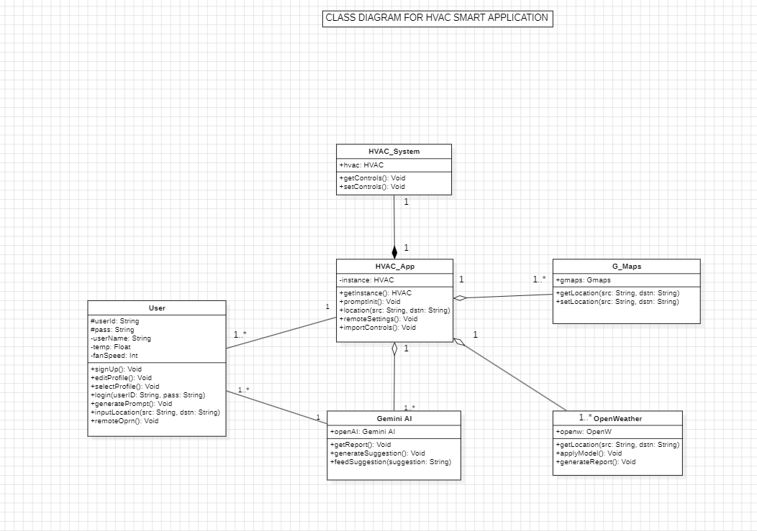

Sequence Diagram:

**4. Non-Functional Requirements**

**4.1 Performance**

* NFR1.1: Process voice commands within 2 seconds.
* NFR1.2: Retrieve and apply weather data adjustments within 5 seconds.

**4.2 Reliability**

* NFR2.1: Ensure an uptime of 99.5%.
* NFR2.2: Handle up to 1000 concurrent users.

**4.3 Usability**

* NFR3.1: Intuitive interface requiring no more than 5 minutes to learn.
* NFR3.2: Clear feedback for all user actions.

**4.4 Security**

* NFR4.1: Use encryption for all data transmissions.
* NFR4.2: Implement user authentication for profile access.

**4.5 Compatibility**

* NFR5.1: Compatible with iOS 12.0 and above.
* NFR5.2: Compatible with Android 8.0 and above.
* NFR5.3: Support integration with major vehicle HVAC systems.

**5. Other Requirements**

**5.1 Legal and Regulatory Requirements**

* OR1.1: Comply with GDPR for handling user data in the EU.
* OR1.2: Comply with CCPA for handling user data in California.

**5.2 Development Tools and Environment**

* OR2.1: Develop using Flutter and Dart.
* OR2.2: Use Firebase for backend services.

**6. Edge Cases and Test Cases**

**6.1 Edge Cases**

* **EC1: Voice command not recognized**:
  + Expected Behaviour: Prompt the user to repeat the command.
  + Test Case: Provide an unrecognized voice command and check for the prompt.
* **EC2: No internet connection while fetching weather data**:
  + Expected Behaviour: Notify the user of connectivity issues and suggest manual adjustment.
  + Test Case: Disable internet connection and attempt to fetch weather data.
* **EC3: Multiple users attempt to adjust settings simultaneously**:
  + Expected Behaviour: Prioritize the first command and notify subsequent users of the conflict.
  + Test Case: Simultaneously input commands from different profiles and observe handling.
* **EC4: User profile data corrupted or unavailable**:
  + Expected Behaviour: Notify the user and default to manual control interface.
  + Test Case: Simulate corrupted profile data and check for notification and fallback behaviour.
* **EC5: Integration with vehicle HVAC system fails**:
  + Expected Behaviour: Provide an error message and suggest troubleshooting steps.
  + Test Case: Simulate a failure in communication with the vehicle system and observe error handling.
* **EC6: Language barrier (voice commands given in languages other than English)**:
  + Expected Behaviour: Notify the user that the language is not supported and prompt for English commands.
  + Test Case: Provide voice commands in languages such as Hindi, Tamil, or Kannada, and check for the appropriate notification and prompt for English commands.

**6.2 Test Cases**

* **TC1: Voice Command Recognition**:
  + Input: "Set temperature to 72 degrees."
  + Expected Output: HVAC temperature set to 72 degrees.
  + Priority: High
* **TC2: Weather-Based Adjustment**:
  + Input: Real-time weather data indicating high humidity.
  + Expected Output: HVAC settings adjusted to reduce humidity.
  + Priority: High
* **TC3: Profile Switching**:
  + Input: User switches from Profile A to Profile B.
  + Expected Output: HVAC settings updated to match Profile B preferences.
  + Priority: Medium
* **TC4: Manual Control Interface**:
  + Input: User manually increases fan speed.
  + Expected Output: Fan speed increased and reflected in the app interface.
  + Priority: Medium
* **TC5: Security Authentication**:
  + Input: User attempts to access a profile without logging in.
  + Expected Output: Access denied and prompted to log in.
  + Priority: High

**7. Appendices**

**7.1 Glossary**

* **HVAC**: Heating, Ventilation, and Air Conditioning.
* **API**: Application Programming Interface.
* **GDPR**: General Data Protection Regulation.
* **CCPA**: California Consumer Privacy Act.

**7.2 Acronyms**

* **SRS**: Software Requirements Specification.
* **FR**: Functional Requirement.
* **NFR**: Non-Functional Requirement.
* **OR**: Other Requirement.

This report summarizes the requirements and specifications for the Automobile HVAC Control Application, providing a comprehensive guide for developers, testers, and stakeholders to ensure successful project completion.